Stowupland Pre-School Newsletter

September 2024

Welcome back to a new term, to all children returning and to our new children and families. We hope you had a lovely summer break and got to spend some time with your families. We have had an amazing first week and we are really pleased with how well everyone has settled!
The autumn term is a busy one, filled with lots of celebrations and experiences for the pre-school children, including Harvest, Fireworks and Diwali, Christmas and a New Year.

Settling in
Please remember that transition is a process, not an event. Over the coming weeks your child may express a range of emotions about being here, and away from you, including those children who are returning to a relatively familiar space. I can personally assure you that the staff are experienced with supporting children in settling in. Please speak to your child’s key person if you have any concerns.
There has been a lot of paperwork sent out over the past week, the list below is what you should have received:
- A Keyperson letter with the name of your child’s Keyworker and what to expect.
- A healthy eating leaflet and oral health advice
- A funding form
- On tapestry I have uploaded the term dates and a ‘What to expect when’ booklet
- In order for us to complete our 2 Year checks this half term and baseline assessments we will also send out a parent/carer form for you to complete.
Our team
Below is the list of staff members, above the lunchboxes at the front of the building there is a list of all staff qualifications and photographs.

Kayleigh – Manager and Safeguarding Officer
Hannah – Deputy Manager and Deputy Safeguarding Officer (Maternity Leave)
Lisa – Deputy Manager and Deputy Safeguarding Officer
Abi – Early Years Educator (Maternity Leave from Oct)
Shelia – Early Years Educator
Ann – Early Years Educator
Denise – Early Years Educator
Kelly – Acting SENCO, Early Years Educator
Kaylee – Early Years Educator
Laura – Early Years Educator

We are very lucky to have a new member of staff; Laura, who has joined our team from another setting. Laura has a wealth of knowledge; she is busy sharing lots of new ideas and making relationships with her new keychildren.

We will be arranging a parents evening for all parents in October to discuss how the children are settling in and next steps.


Autumn term focus book selection

This term we will be exploring the popular ‘Handa’s surprise’ by Eileen Browne.
This book providers the opportunity to talk about what the children can see through the beautiful illustrations. This book provides an insight to a different culture, and we will provided opportunities with food tasting and new animal resources. As well as a story sack for the children to re-tell the story.

We will also be looking at artwork by Yayoi Kusama particularly her artwork with pumpkins.

Please don’t forget our lending library, please take a book to read and share at home and return when you have finished.

Sickness
Children and young people who have a positive test result for COVID-19 should not attend the setting for 3 days after the first test.
If your child has a high temperature and is unwell, they should not attend the setting.
If your child has sickness or diarrhoea, they need to stay at home for 48 hours after the last bout.
We advise that children should be off for the first 48 hours following new medication/antibiotics.
We can only give prescribed medication to your child and a form will need to be completed.
We have recently updated our policy on Hand, Foot and Mouth this has been uploaded on Tapestry.

The Committee & AGM
The Preschool is run by a committee of parents. It is vital we have parent/carer support in order to keep the preschool open. Our committee oversees the running of the setting and supports with lots of fundraising. If you have some free time and would be interested in finding out a little more about the committee, we will be holding a meeting on Thursday 24th October 2024 at 7:30pm. If you are interested in joining the committee or finding out more, please come to the meeting ahead of the AGM after Christmas. Alternatively, please speak to Kayleigh or Lisa.

If you would like to contact Vicky, our Chairperson her email address is chairperson@stowuplandpreschool.org.uk

Fundraising Committee

FUNDRAISING UPDATE - WHY FUNDRAISING IS SO IMPORTANT TO US
Some of our new families may not know, but as a charity we rely on fundraising to help towards buying new materials for our setting, so the children can flourish in their learning and play.
Our fundraising group are part of the Committee and they come up with ideas throughout the year to raise monies.
If you have any ideas for events and/or would like to get involved, please let Kayleigh know.

We are so thankful for all donations last year, all funds raised went towards our ‘Garden Make-Over’. It has been AMAZING to use the whole garden at its fullest potential this past year. The children have played football, had summer picnics, we have read stories, and the children have been able to extend their role play and imaginations.

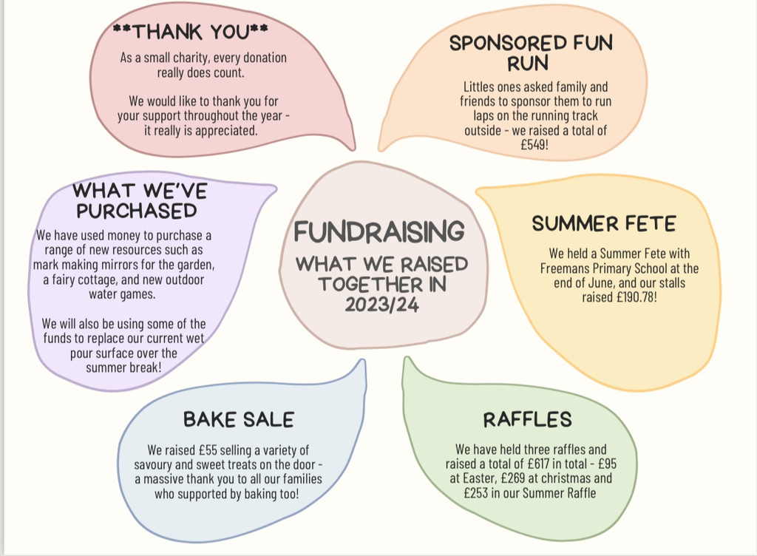

General Reminders


The weather is cold and wet, we kindly ask parents/carers to provide a named warm coat and named wellies as our garden gets very muddy and the mud kitchen is a proving to be very popular. We encourage children to change into their wellies when outside, which can be kept at preschool or brought in with your child on the days they attend. The children have access to the outside garden throughout the day.

Please could you ensure that your child’s lunchbox and drink bottle are clearly labelled with their name, to avoid mix-ups.
We encourage all children to make healthy choices at Lunch-Time; eating sandwiches and fruit/vegetables before a snack or treat. We also try to encourage children to try everything that you pack for them.
Please talk to us if you are finding that your child comes home with lots of food remaining in their boxes, and will do our best to find ways of encouraging them further at lunchtimes.
*Please do not pack any NUTS in your child’s lunchbox due to allergies.


We respectfully remind parents to park in the car park at the Village Hall when dropping off and collecting their child from Pre-School. Parking in the School/Church layby is strictly not permitted at any time.

It is stated within our Attendance Policy that if your
child is unwell please call or email the setting on 01449 678550 or admin@stowuplandpreschool.org.uk in the morning ideally before 8.30am.

Tapestry
Everyone should have received a letter confirming their child’s keyworker. If you haven’t, please speak to Kayleigh or Lisa. Our daily ‘Snap shots’ have started, and individual observations will start this week/next. Please note that all staff are spending quality time with the children extending their learning and development.

Consumable charge
Some of you may be aware that the amount we receive for each funded child who attends our setting has dropped significantly. With this in mind, we ask parents for a ‘consumable charge’ towards the cost of the seasonal activities, cooking, animal encounter and Christmas party etc which we provide at Pre-School. Stowupland Pre-School is a Committee run setting, which has charitable status. We are a non-profit organisation, and any profits we generate go directly towards the running of the Pre-School.

TERM DATES

You will find our term dates on Preschool News: Please see some extra important dates below:

Important Dates-

25th September – Harvest Festival: Food donations
4th-10th October – World Space Week
Wednesday 23rd October and Thursday 24th October – Parents Evening
Thursday 24th October 7:30pm – Committee meeting
1st November - Diwali

5th November – Fireworks Night
11th November – Remembrance Day
W/C 11th November 2024 Dress up week for Children in Need
Wednesday 18th December 2024– Christmas Party Hour (TBC)
Wednesday 15th January 2025 – School application Closing date

If you have any Safeguarding concerns relating to children or adults please contact Customer First on 08088004005

